The title is set in bold 16-point Times New Roman. The first letter of the title should be capitalised with the rest in lower case

Author Name¹, Author Name²*, …, Author Name^{n-1} and Author Name^{n} should be typed in 13-point Times New Roman. The style for the names is First Name then last Name, with a comma after all but the last two names, which are separated by “and”. Do not use academic titles.

¹Affiliations of authors should be typed in italic 11-point Times New Roman.
²They should be preceded by a numerical superscript corresponding to the same superscript after the name of the author concerned
³Please ensure that affiliations are as full and complete as possible and include the country
*Correspondence to: include the email addresses of the corresponding author(s). Please use the asterisk (*) symbol for the corresponding author information.

This is the main text of the abstract. Your abstract should fit on one A4 size page. The text of your abstract should be formatted as follows:
- 12-point Times New Roman.
- The text should be set to single line spacing
- Paragraphs should be justified.
- Margins of 3 cm up and of 2.5 cm (left, right and down)

Figures, tables, and or schemes may be added as long as the one page limit is not exceeded.. Please remove any indent for captions and titles.

Table 1. This is the Caption of Table 1, bold, size 11 Times New Roman
Experimental data | Data 1 | Data 2
Samples 1 | 1 | 3
Samples 2 | 2 | 4
… | … | …
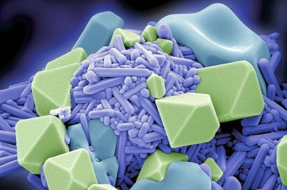
Figure 1. Figure captions, bold, size 11 Times New Roman

References
[1] First Author, Second Author,…, n^{th} Author, Journal X Volume, page (year).
[2] First Author, Second Author,…, n^{th} Author, Journal X Volume, page (year).
The authors, in the form: initials of the first names followed by last name (only the first letter capitalized with full stops after the initials), the journal title (abbreviated), the volume number (bold type), the article number or the page numbers, the year of publication (in brackets). See example below.

[1] A.Taoufyq, V. Mauroy, F. Guinneton et al, Journal of Materials Research Bulletin, 70, 40- 46

(2015)
In the end, please don’t forget to rename your template file as: Lastname_cimae-2018.doc (Taoufyq_cimae-2018.doc), and just submit it.

